Sustainibread

van hall larenstein | agora 1 te leeuwarden

Bread over date

reducing the bread waste

Title page

Students: Cilo Cecil (20612)

Tompson Gaihai (19124)

Matthijs Langeveld (13031)

Lisan Siemonsma (13653)

Laurens Terraneo (10810)

Anouk Ytsma (12387)

Lobke Zijlstra (13298)

Institute: Van Hall Larenstein

Agora 1,

8934 CJ Leeuwarden

Stichting Grien

Rengersweg 23

9062 EA Oenstjerk

Module: LVT331

Date: 31-01-2019

Summary

Bread is one of the most thrown away food in the Netherlands, annually there is 160 million kilograms of bread thrown away. Bread is presented as a fresh product and has to be freshly baked each morning, which leaves a large waste stream behind. Bread waste is currently used in breadcrumbs, croutons and toast.

Foundation Grien wants to reduce the waste stream of bread by putting a new product on the market made with old bread. Foundation Grien has asked Sustainibread to develop a new product that uses a large percentage of old bread.

The development of a new product is performed in different phases; orientation-, (concept) development- and product definition phase. In the orientation phase there is orientated on the market, target group, decision points and different products that can meet the requirements of the target group.

In the (concept) development phase, the products that were orientated during the orientation phase are carried out. With the decision points, the amount of concept products is reduced which leads to a final product. The final product is defined in the last phase, the product definition phase, in this phase the product is adjusted to the results of the expert panel and later to the consumer panel. This results in to a product that meets the requirements of the target group.

After the market research a target group was established, the target group consists of people from an age of 18 till 50/70. These people do their own groceries shopping. Besides this argument it is also needed that the target group wants to try new products and be more sustainable. The decision points were adjusted to the criteria of the target group.

During the concept development phase 8 products were chosen to make during production. After production the expert panel tested the products and decided on the product based on the production time, difficulty of production and the amount of bread used in the product. After 2 production days a final product was chosen, the raspatat.

The raspatat contained a large amount of bread and was easy to make. During the product definition phase raspatat was adjusted to the results of the expert panel. There were 3 variations made, 50% bread with 50% potato powder, 100% bread with 50% potato powder and last 50% bread and 100% potato powder. The results of the expert panels showed that the variation with more bread than potato powder was the best match. After adjusting the recipe according to the results of the expert panel, the consumer panel tasted the product. The raspatat was then again adjusted to the results of the consumer panel. To be sure the product met the requirements of the target group, another consumer test was carried out. The results of the second consumer test are promising.

The raspatat contains a lot of bread and reduces the waste stream of the old bread. The advice is to sell the fries in biodegradable sachets with the labels made for the raspatat and to freeze these before selling to the consumer. For the marketing it is advised to use social media platforms to let consumers know the product is available in the supermarkets. The target group that has been chosen is very active on different social media platforms. For the older consumers there has been a press release made to send to local or national news paper editors.

Index

1 Introduction 7

1.1 Parties Involved 7

1.2 Project Structure 8

2 Theory 9

2.1 Food product development 9

2.2 The phases of developing a product 9

2.2.1 The orientation phase 9

2.2.2 The (Concept) development phase 9

2.2.3 The product definition phase 10

2.3 Sensory Analysis 10

2.4 Special ingredients 10

2.5 Labelling 11

3 Orientation phase 13

3.1 Method of approach and execution 13

3.1.1 Market research 13

3.1.2 Consumer needs 13

3.1.3 Decision points 14

3.2 Results 14

3.3 Conclusion 14

4 Concept development phase 15

4.1 Method of approach and execution 15

4.1.1 Idea generation 15

4.1.2 Idea selection 15

4.2 Results creativity session 16

4.2.1 Chocolate paste/bread sauce 16

4.2.2 Pizza Crust 16

4.2.3 Chocolate balls 16

4.2.4 Donut 16

4.2.5 Chips 16

4.2.6 Bread Cereal 17

4.2.7 Breadball 17

4.2.8 Raspatat 17

4.3 Conclusion 17

4.4 Try out production day 18

4.4.1 Chocolate paste/bread sauce 18

4.4.2 Pizza crust 18

4.4.3 Donut 18

4.4.4 Chips 18

4.4.5 Bread cereal 18

4.4.6 Breadball 19

4.4.7 Raspatat 19

4.4.8 Chocolate balls 19

4.5 Conclusion 19

5 Product definition phase 20

5.1 Raspatat definition 20

5.1.1 Shelf life 20

5.1.2 Price 20

5.1.3 Efficiency 21

5.2 Sensory Analysis of prototypes 23

5.3 Expert panel tests 24

5.4 Consumer tests 26

5.5 Results 27

5.6 Conclusion 27

6 Final advice 28

7 Press release 29

8 Bibliography 30

Appendices I

I Results creativity session I

II Recipe chocolate paste/bread sauce III

III Recipe Pizza crust IV

IV chocolate balls V

V Recipe donut VI

VI Recipe Chips VIII

VII Breadball IX

VIII Recipe Raspatat X

IX Bread Cereal XI

IX Recipe Chocolate Balls XII

X Questionnaire expert panel test XIII

XI Questionnaire consumer tests XIV

# Introduction

Food waste is a big issue in nowadays society, especially bread is a frequently thrown away product. The waste stream is used in products like croutons, breadcrumbs and toast. These products are used daily, but not in large quantities. Foundation Grien wants to change this bread waste stream to develop a new product that is eaten or used daily and which contains a lot of bread. This will result in a decrease of the food waste and a more sustainable future.

## Parties Involved

SustainiBread is an advising agency that aims to reduce the magnitude of the current waste stream of bread. Bread is one of the most thrown away food in the Netherlands. In 2017 approximately 160 million kilograms of bread were thrown away. By order of foundation Grien (a foundation that is focused on realising a ‘circular’ closed food circle), SustainiBread is to develop a product that utilises old bread as a resource.

SustainiBread consists of 7 students. The group consists of 4 food technology students, 2 exchange students and a chemical engineering student. The combination of this diverse knowledge base is the result: an individual advising agency with enough knowledge to provide innovative solutions. Below an organogram is shown depicting the members of SustainiBread, the person of contact for Foundation Grien and the tutor from van Hall Larenstein for guidance of this recently formed company.

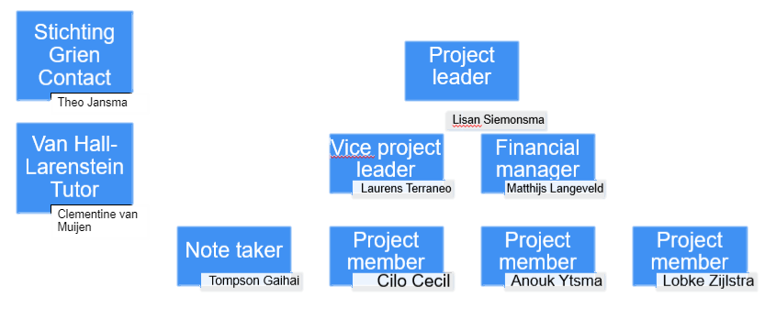

Figure 1 Organigram

The project leader will have final responsibility and will guide the weekly meetings with the tutor. When the project leader is not present for meetings, the vice leader carries this responsibility. All group members contribute to the project of food product development and their activities contribute to the formation of advice towards the client: Foundation Grien.

The main goal of SustainiBread in relation to the assignment of Foundation Grien is developing a product that is eaten on a mass scale to reduce bread waste as much as possible.

Foundation Grien aims to connect, inspire and activate parties related to food waste reduction. Grien focuses on realising a circular ‘closed’ food cycle and bring food back to its intended purpose: humane consumption. Grien intends to operate under the name ‘de Verspillingsmarkt’ (literally translated: The Waste Market) and become the knowledge centre of the northern part of the Netherlands specialising in waste reduction in the food cycle.

By researching the possibilities in product development where rest streams, side streams and spoils are utilized as the main resource, the Waste Market aims to function as the driver for cyclic product generation and waste reduction.

Foundation Grien has a cooperation agreement with a variety of institutes and companies, which are listed below:

* Province of Fryslân
* Noardlike Fryske Wâlden
* Kennis en Innovatiehuis Noord-Oost Fryslân
* Rabobank
* Van Hall-Larenstein / Food application Centre for Technology
* Hanze Hogeschool
* Other stakeholders (Kaay, Greydanus, LTO etc.)

## Project Structure

The development of a new product follows several phases; the initiative phase, the development phase, the definition phase and the realisation phase. The report is structured in this order. First the theoretical basis is defined that underlies all phases. Then each phase is worked out in more detail with a final advice for Foundation Grien on how to tackle the problem of bread waste.

In this case Foundation Grien initiated the development of a multitude of products derived from big waste streams. One of the waste streams is old bread. In the initiative phase assumptions are made which are the basis for the development of a new product. Besides these assumptions, boundaries are set for the complete process. In the case of Foundation Grien these are simplified to:

* The production process must be highly efficient in terms of energy consumption and utilisation of resources.
* The developed product has a focus on being mass consumed.
* The production process must be scalable to adapt to variating demand in the future.

The scope of this project stretches into the realisation phase. SustainiBread functions solely as a researching and advising agency. The realisation phase is defined in this report but only as an example for Foundation Grien. The product definition is handled by SustainiBread. The resulting conclusion is an advice towards Foundation Grien. How Foundation Grien desires to implement this new product in the market (e.g. realising sales). During the course of 10 weeks a new product is to be developed and prototypes presented to Foundation Grien.

SustainiBread is given a financial budget of €50 for the procurement of raw materials to produce prototypes. The ingredients to be bought for production that are not available in the production plant are to be paid for from this budget. The financial manager is responsible for expenses paid for from this budget. With sustainability and low price in mind, SustainiBread uses waste bread from a local bakery as a resource.

All activities concerning introducing the final product to the market are to be assessed and executed by Foundation Grien.

# Theory

## Food product development

Food product development can be defined as the complex of business activities the business utilizes to adapt its most important means of existence – the sold inventory – to internal and external demands. Internal demands being viewed from a market- and strategic standpoint and external demands being viewed from the consumers- and environmental standpoint.

The complexity of the current market makes developing a new product equally complex. It is very important that a structural approach is maintained when developing a new product. In general, product development follows these steps:

1. Concept development
2. Product- and process development
3. Implementation

In this report the phases that underlie the development of a new product in which the main resource is unsold or old bread is worked out.

## The phases of developing a product

### The orientation phase

In the orientation phase the market in which the product will end up is analysed. By conducting market research certain questions regarding the yet to be developed product are answered. Questions like ‘What is the consumers behaviour regarding products related to bread?’ or ‘How does sustainability of a product influence sales?’ are good examples of how the advising agency orients itself towards the market. Based on the information from the market research, a target group is defined. The development of the product is steered towards the needs of this target group.

After having a clear orientation of the direction SustainiBread has to move when developing a new product, the concept development phase is initiated.

### The (Concept) development phase

In this phase multiple product concepts are devised with the consumer needs in mind. These consumer needs can be technical (as some products have to have a certain functionality) or emotional (as some if not all products bring forth a certain experience or feeling). There are different approaches to accurately determining consumer needs. There is the analytical approach and the pragmatic approach.

The analytical approach requires that consumer needs are very clearly defined. An analysis on the required functionality is conducted. This in turn defines the attributes a product should have from the perspective of consumers. Based on these attributes a concept description is made. This description is then tested against the consumers opinions and expectations. The description is fine-tuned until it meets all of the expectations of the consumer.

The pragmatic approach works in the opposite direction. Concepts are sketched out and compared to the expectations and needs of the consumer. These are then in turn fine-tuned as well.

During the development phase, creative ideas are crucial for developing an original (and in terms of problem solving, applicable) solution or product. To generate ideas, creativity sessions were organized. During these sessions’ idea-generation techniques were used to contrive a range of possible product concepts.

Idea generation techniques can be divided into three categories:

* Analytic-systematic techniques; morphological box technique or progressive abstraction for example.
* Intuitive techniques; brainstorm for example.
* Analogies; synectics, in which ideas come to apparition by sidetracking to a completely different workfield.

When the ideas are generated, a selection out of all the ideas is made based on how they fulfil the requirements.

The concept development phase forms the basis for the product definition phase.

### The product definition phase

In this phase consumer demands are translated to objective, tangible and realizable technical demands. This is done by quantifying aspects of the product such as taste, look, feel and smell into different attributes with scores. Sensorial analysis is very important for defining how well the product scores in the given attribute categories. The expectations of the product are tested by means of prototypes which represents points of improvement for the prototypes. Furthermore, prototype development can grind to a halt if a prototype does not fulfil the expectations sufficiently. Based on certain criteria which function as decision points, a prototype is further refined or dismissed from production to increase focus on prototypes that have more potential. The details concerning quantification is worked out in the sensorial analysis section of the product definition phase. Eventually one or more final products result from the product definition phase. These products will then be perfected to the point where they can be sold in stores/supermarkets. When this occurs, the realization phase is set in motion.

## Sensory Analysis

Sensory research is applied in various ways within the food industry. It’s done by an expert and the consumer. The expert panel are good tasters, they have been selected, trained, and the panel is also regularly monitored for reliability, reproducibility (duplo measurement) and accuracy. The products are tested on the expected sensory characteristics as color, format, crunchiness, taste and aftertaste. When the product meets all sensory characteristics, it will be tested by the consumer. The consumers are normal tasters and a target group that is chosen, they test hedonically. They determine about the product, it is about what does the consumer wants, does the product appeal.

## Special ingredients

Bread is a good source of carbohydrates and nutrients including magnesium, iron, selenium, B vitamins and dietary fiber. The three types of bread used are white, whole grain and brown bread. (The difference between bread, 2018)

**White bread**

White bread is made from refined flour. The wheat kernels are processed to remove the bran and the germ, leaving only the endospore. Although the endospore is the largest part of the grain, it contains the least nutrients. This results in a lighter texture and flavor as well as fewer nutrients. (Jessica Bruso , 2018)

**Whole grain bread**

Whole grain bread Is made by using flour that has been mashed using the whole grain of the wheat.Apart from wheat, whole grain bread can include other whole grains, such as whole barley, brown rice, whole grain oats, and rolled oats, among others all of which are rich in fiber, vitamins, and minerals. (Grace Elkus, 2018)

**Brown bread**

Brown bread is often a mixture of whole wheat flour and white flour with added ingredients for color, such as caramel. The bran in whole wheat flour provides fiber and the germ provides protein and Vitamin E. ( Toby Amidor, 2018)

## Labelling

A lot of factors come into play when a customer is (sub-) consciously making a consideration whether to buy a product or not. The moment a customer is walking through the isle in a supermarket your product has to stand out and/or fulfil their needs.

To make the product stand out and catch the attention, the packaging has to reflect a feeling or taste of what the experience of consuming that product resembles. As the final product is chosen, the sensorial analysis of the prototypes are a guideline for the experience the packaging has to represent. The colours of the food (with an accompanying contrasting colour) are used as the base for the palette used for the packaging.

The product is recycled, and the most important main constituent is old bread. The image(s) on the package will have to reflect this. The actual product will be depicted together with bread to show the significant use of bread as a resource. This will also allow to promote the product with a ‘green’ or ‘eco’ indication. With modern day environmental troubles being resolved by circular and sustainable products, an indication of this product being good for the environment by attacking waste streams will stimulate purchase of the product.

**Label information:**

According to ordinance 1169/2011 (regulation concerning distribution of food information to consumers) as stated by the European Parliament 25-10-2011, a high level of health protection has to be maintained when informing consumers of a food product. A foundation has to be provided on which a customer can make a well informed and thought out choice and safely use foodstuffs, with special attention to health-, environmental-, economical-, social and ethical aspects.

If a product is destined for consumer or catering industry use and pre-packaged, the package has to adhere to a great amount of requirements. These requirements are:

* Name of product
* List of ingredients (ordered from high to low amount)
* Allergens
* Amount of ingredients
* Net weight
* A best before date
* Special storage guidelines and/or terms of use
* Name and address exploiter
* Country of origin
* Volumetric percentage of alcohol
* Nutritional value

All of this information is to be presented on the packaging.

As the production of all prototypes is monitored as well as the use of ingredients, four of these points are covered. The best before date is influenced by the nature of the product (yeast content, storage conditions, means of preparation etc.), and will have to be determined by testing. This in turn is accompanied by special storage guidelines. The net weight per packaging is determined when the final product is chosen. The country of origin will be the Netherlands, as the product is produced locally. The nutritional value can be determined according to the amount of ingredients used and their corresponding nutritional value (taken from RIVM database). However, the process of preparation adds calories. To accurately depict the nutritional value, a calorimeter will be used for the final prepared product, and detailed workouts of sugar/fat content, amount of fibre etc. are calculated according to the amount of used ingredients.

# Orientation phase

The orientation phase of the food product development consists of research on the market and the consumer and making and deciding on the decision points of the product that are made. The decision points control the decision on a product in the following phases, therefore the decision points must be as specific as possible to avoid problems in the future.

## Method of approach and execution

In the coming subchapters the methods of approach and execution are discussed.

### Market research

Dutch consumers spent a total of nearly 2 billion euro on bread in 2003. Annual consumption of bread has been an average 60 kilos per person for years now. On average each inhabitant spent 121 euro on bread in 2003 but during the period 2011-2016 per capita consumption of bread decreased by 9.2 kg (-15.3%) in the Netherlands. Bread consumption is not likely to grow dramatically since bread is eaten in nearly every household and it is likely unrealistic to expect bread to make any major changes over time in the consumption. Studies found that there continues to be increased demand for greater variety of bread and bread products. There is a continued growth in morning goods and speciality breads with lots of opportunities for innovation. With respect to product innovation and development of health trends consumers are more likely to buy products which are nutritious with less calorie content and products that contain wholegrain, fibre and longer shelf life. Consumers are also interested in natural, convenience and indulgence and growing out of home consumption meaning less time spent on home food preparation and consumption. The current varieties of products made with bread are beer, liquor, croutons, buns, bread crumbs etc. The market research was done on social media platforms like Facebook, Instagram. We had conducted survey’s in the form of questionnaire and polls about the variety of bread products which were known and eaten by the Dutch in the Netherlands. Surveys have helped us gain insight on the trends, to identify target groups and on the budget of consumers willing to spend money to try new products. The result of the market research is discussed in the later part of the report.

### Consumer needs

The goal of a customer needs analysis is to understand the customers’ needs and their position in the overall market. The consumers are likely to buy products which meets with their budget or constraint. Product needs to be cheap as different customers have unique budget which they buy the product. A good shelf life without compromising the product quality indulges the consumer to buy the product. Sustainability is also taken into account in terms of production and transport costs and they should have a packaging that is environmentally friendly and recyclable. The package is also taken into consideration as it makes the product look good or bad, expensive or cheap. Package should be conveniently easy to use and open, attractive and unique as this will catch their attention towards the product in the market and enhance the overall experience of the consumers while trying the product.

### Decision points

The decision on what food products to develop relies on the market needs and what consumers prefer because at the end of the day it is expected that the food products should be capable of being sold out efficiently. Therefore, the criteria to be used for selection of the products is as follows:

1) Generally, the products to be selected should:

* be for human consumption only and they should be consumed regularly daily.
* incorporate large quantities of bread in their production, this is important as the main goal of the project is to reduce the level of food waste of old bread.
* be capable of being used in various ways, for example they can be used to make different food dishes.
* be sustainable, in terms of production and transport costs and they should have packaging that is environmentally friendly and recyclable.
* be of a certain appearance and standard that is appealing to the consumer.
* have a good shelf life.

2) Specifically, the products to be selected should be chosen by:

Use of sensorial evaluation, where by the trained assessors use analytical analysis to determine the product characteristics in terms of taste, smell, touch and this helps the agency to have confidence in their products quality and know what changes can be made. Another part of sensorial evaluation is use of the Hedonical analysis, whereby the agency determines the consumer’s preferences by use of the consumer’s opinions (consumer needs). Therefore, by use of these analyses the agency will determine their conclusion on the products to have.

## Results

Out of the market research done by use of social media and surveys, it came that there are few products already made with old bread. These are: beer, liqueur and croutons. So, when thought of the product the group should keep in mind that these won’t be selling as good as new products. For products that are a parody on another product there should be looked at the market afterwards. After consumer research it was clear what kind of target group we were aiming on. The target group is Dutch people around the ages of 18 till 70 whom logically do most of their own groceries and are interested in buying products that are sustainable. As well as the consumers that are willing to take a risk at trying new products. Mostly those people will buy groceries for their family or in the case of students for themselves. That’s also why the product needs to be cheap and take a lot of the waste stream from the bread. The consumers mostly don’t want to spend a lot of money on their grocery’s, only when it is seen as a luxury product. Therefore, when looking at the decision points it can be said that for deciding the product all the decision points where taken in thought together with the consumer needs of the target group.

## Conclusion

To conclude the market research and consumer needs, the target group identified is between the ages of 18 till 50 as they are the people who like to try new products and have wide range of options which is healthy, cheap, ready to eat, has less cooking time, is more sustainable and has a longer shelf life. Consumers are more likely to buy products which are not common in the market than the regular products as the communities are also having more international presence with people coming from different parts of the world. The next phase of the report, the advising agency will generate ideas excluding the products mentioned in the market research as they are already in the market with help of techniques like brainstorm. Ideas generated from the creativity sessions will help to fulfil the needs and demands according to the specific target group.

# Concept development phase

## Method of approach and execution

For the concept development phase different ideas of products were worked out. The ideas were generated by use of a classical brainstorm in combination with positive brainwriting. On Monday 26th of November a creativity session occurred. The session is worked out in the section below. All the final ideas are added in the appendix I Results creativity session.

### Idea generation

First there were questions made to define the idea’s that should come out of the session. The group came up with 2 final questions, which were:

1. How can the team make sure everybody wants to try the product?
2. How can the team make sure that the market value goes up and the waste goes down?

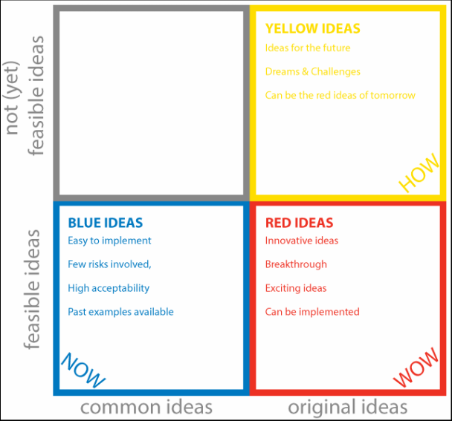After these questions were stated, two kinds of brainstorms were performed. The first brainstorm was a regular one, in which was written down, on a memo pad, whatever ideas come to mind. The second brainstorm was one where the alphabet was written down and with every letter the upcoming ideas were noted.

### Idea selection

After all these ideas were written down, the ideas were ordered into a COCD box, represented in figure one. After sorting the ideas three ideas where picked to be the best idea in the category. For blue this was an alcoholic drink, for red this was crispy chocolate balls and for yellow this was a bread spread.

Figure 2 COCD box

After reading al the ideas and selecting the best according to the group, recipes were made. The sensory analysis is performed by the group members, the criteria for continuing with the products are; the amount of bread used, everyday use or frequently eaten products, the taste and appearance.

Section 4.2 discusses the chosen ideas and their production.

## Results creativity session

### Chocolate paste/bread sauce

During the creativity sessions the idea of putting bread on bread was generated. Because chocolate paste is a commonly used product in the Netherlands, it is easier to switch to a product that is similar to the product consumers already use. Another product idea is the idea of a dipping or snack sauce that contains bread. The chocolate paste will be made as an original chocolate paste and then a different percentage of bread paste mixed in to it. The bread sauce is made the same, with mixing a different percentage of bread paste into the sauce. The recipes can be found in appendix II Recipe chocolate paste/bread sauce.

### Pizza Crust

During creative sessions, the idea to use bread to make pizza crust was made. Pizza especially requires a large quantity of bread which can reduce the wastage of bread. It’s a delicacy that everyone likes to eat. It’s ready to cook pizza base, where consumers can put their own toppings. A lot of bread with varieties such as brown or white bread can be used to make pizza dough. Recipe of pizza crust can be found in the appendix III Recipe Pizza crust

### Chocolate balls

During the idea generation session, the well known candy ‘Maltesers’ came up as an idea. The reason for this was that Maltesers are easy to consume, have a crunchy center and due to their coating possibility makes for endless variation possibilities. To tackle the bread waste problem, big scale consumption is an important factor. The chocolate balls can be consumed during breakfast (as an addition to cereal for example), during lunch (through yoghurt products) and after dinner as a dessert component. By creating a product that can be consumed throughout the day, the possibility of big scale consumption increases as well.

The product will have to resemble the same experience as Maltesers. They have to be crunchy, sweet and coated with (preferably) chocolate. The crunchy center (or merengue) is produced by substituting malt extract by old bread. The goal of this substitution is to create a bread flavor as well. The resulting recipe can be found in appendix IV chocolate balls.

### Donut

During the creativity sessions the idea of making donuts out of bread was generated. Because donuts are a product that is made out of a dough from flour, what is easy to replace with bread. A lot of bread can be processed in a donut. Since the whole donut consists of bread instead of flour. Donuts are not daily consumed products, besides that donuts have a broad target group and it is regularly consumed as a snack or treat. The recipe can be found in appendix V Recipe donut.

### Chips

In the creative sessions, the group also came up with the idea of making chips. Chips is a mass-produced product so if it would work, we could reduce a lot of the ‘bread-waste stream’. At first the idea was to make chips with air bubbles inside a little bit like the cheese snacks or bear chips. But because that was too hard to achieve the recipe of pringles was used instead. The only problem was that there is no recipe available online, so the ingredients where taken from packages and after a while a video of ‘how it’s made’ was found so that was the head lead in how the chips would be produced. The final recipe can be found in appendix VI Recipe Chips

### Bread Cereal

Amidst the creativity session, one of the most popular food stuffs the citizens of Netherlands consume, is cereal almost every morning of every day. Due to this reason, it was ideal to have an idea of making cereal from bread, and this could be possible since cereals are made up from carbohydrates and bread is a carbohydrate on its own. Since it is not common to have cereal made from old bread, this seemed to be an interesting idea which however was posed with some challenges. The cereal was expected to be crunchy when eaten directly and when it was to be placed in milk, it was expected to become soft. To add on, the cereal was also expected to have a sweet taste that makes it enjoyable to eat. The cereal consumed a lot of bread during its production as only the ingredients used were bread, sugar, vanilla extract, water and salt. The full recipe of the bread cereal is found in appendix IX Bread Cereal

### Breadball

With the brain session many ideas have emerged. Including a bitterball / breadball. A breadball / bitterball could be made with bread. There are some videos on the internet, mostly from India. The ideas of the group and the films, 2 recipes have been released. 1 recipe is a whole bread around it and with the other recipe there are pieces of bread inside the ball. In the exploratory phase, these 2 recipes were carried out. The 2 recipes contain the same ingredients. The expectation was low, a ball with bread in it does not really get you excited. The choice fell on the bread pieces in the ball. The next phase is working with various ingredients. Also, pieces of tomato and carrot were put in, other raw materials that Mr Jansma is working on. The expectation with what Dutch vegetables in it was higher. During the meeting, 3 products were chosen that would be further developed, including the breadball. The week after, not only a ball was made, but also a burger. The burger was an alternative of the ball, because more burgers are consumed than a ball. The expectation was quite high, because a lot of bread is processed. The recipes are displayed in the appendix VII Breadball

### Raspatat

After meeting with Foundation Grien, the idea of raspatat was generated. Raspatat is a typical dutch snack made of potato mash. Because fries are eaten often in the Netherlands it can have a great market value. The percentage of bread is variated during the concept development phase and will be adjusted to the consumer needs. Especially if people are aware of what they eat and want to be more sustainable. The recipe of raspatat can be founded in appendix VIII Recipe Raspatat

## Conclusion

The creativity session was very useful because of the surprising ideas that were generated. The recipes were made according to the interpretation of the group. The recipes are ready to be made in the try out production day. After producing the products, the criteria for continuing or not continuing are used.

## Try out production day

The results of the production days were surprising, the criteria for continuing or not continuing were applied to the product. Finally, the final product could be chosen according to the criteria and the preferences of foundation Grien.

### Chocolate paste/bread sauce

With the production of the chocolate paste, 12 different percentages of bread paste were mixed in to 100 grams of chocolate paste. After the production the chocolate pastes were tasted by the different group members. The taste of the chocolate paste without bread paste was good but, with the bread paste percentage increasing, the taste, the mouthfeel and the colour of the chocolate paste decreased. The sauce with the 4 different percentages of bread paste were also tasted with the group. The taste of the sauce was good even if the bread paste percentage was increasing.

### Pizza crust

After Pizza crust was made, it was sampled by the group members. The pizza crust in general didn’t taste good, the texture was rather tough and dry. It also came into consensus that we drop the product because of lack of taste, looks and quality.

### Donut

Within the recipe of donut there has been made one variation in which all the flour has been replaced with bread (a mix of different types of bread). The production of donuts went well. The product was tested by the group members. The taste of the donut was good, it was not noticeable that the product was made of bread. In addition, the product characteristics were not what you expect from a donut. The donut was hard on the outside and soft and slightly sticky on the inside. Unlike the donut from the supermarket that is soft on the outside and dry and airy on the inside. From this we can conclude that the donut of bread has to be further optimized. This is possible by frying the donut at a higher or lower number of degrees Celsius, this could improve a large number of product properties. There has been decided to not further optimize the product, since donut is not an often eaten product.

### Chips

The chips were good after making it but stayed soft on the inside. So, when that was found out different changes where tried with the recipe, like more or less water, different frying temperatures or oven baking the chips after they were fried. After every trial the product was tasted by the whole group and everybody shared their opinion. But sadly, no matter what we tried made the chips really chrispy. Therefore, after a while the suggestion of the company Grien came about maybe trying to make fries instead. The group tried to make that, and it was a way better product so after that day no more chips where produced.

### Bread cereal

Production of the bread cereal seemed to be far-fetched because it was time consuming that is, over 3-4 hours or more. The most burdensome part of the production was the drying of the cereal which not only required the food product developer to figure out the right temperatures which don’t make the cereal too dry and hard. Having said this, the bread cereal was dry and hard (not crunchy at all) and when it was added to milk, it would not soften out making it unpleasant to consume. In terms of taste, the cereal was not sweet enough indicating the need for addition of more sugar or vanilla extract to it. From the look of it, it is probable that the bread must be mixed either with corn meal or another appropriate ingredient to improve on the cereal texture and drying capabilities that result the cereal to become crunchy and soft. Therefore, the bread cereal was not a good choice of product to focus on during the project.

### Breadball

For the first 2 recipes, it quickly became clear which one would continue. The bread ball with bread around it was sombre and not delicious. The breadball with pieces of bread in it was a little bit spicy but liked by most students. The next step has been taken with this breadball. The breadball contained less spicy spices / red pepper. Various vegetables were also processed such as carrots and tomatoes. Mr. Jansma found the product excellent and was very satisfied. The last time trial production was also made vegetable burgers on the idea of Mr Jansma, unfortunately the balls were tastier than the vegetable burgers. The burgers were baked in the pan while the balls are always baked in the fryer. The ball has a hard crust and is compared to a bitterball, whereas the vegetable burger was not so crispy, and the taste differed than the ball. The choice has been made to continue with French fries and leave the breadball.

### Raspatat

The product was easy to make during the production day, it did not take a lot of time and the mixture was easy to handle. After frying the fries tasted good and the bread was not noticeable, because the group members liked it and it was easy to make the fries were chosen as a final product.

### Chocolate balls

During production of the chocolate balls a number of problems arose. The main problem was the texture. Due to the bread being added, the merengue came out of the oven quite hollow. It was extremely sweet and still a bit sticky on the inside. The result did not resemble Maltesers at all. Apart from the texture being off and the taste being too sweet some other problems could not be overcome. The ingredients for the recipe are expensive and unhealthy. Furthermore, the stability of the merengue in milk was virtually non-existent, rendering the product inedible in the intended medium.

## Conclusion

During the production days all the products were made once or more times to get a full image of the products and the capacity of bread that was going to be used. The chocolate paste/bread sauce, pizza crust, donut and chocolate balls were the first products that did not meet the criteria. The chips and cereals were not chosen in a later stadium due to different problems with the product itself. The breadball and the Raspatat were chosen in the last stadium, because the breadball did contain less bread than the raspatat, the raspatat was chosen as the final product. The raspatat was also highly liked by the client.

Finally, the creativity sessions were very useful due to the products that were generated and made, because of the creativity sessions the final product was invented. The recipes that were made before the try outs were followed during the try outs and resulted in good products to taste. After producing the focus was changed to less products and finally to 1 product, the raspatat. Raspatat is the product that is focussed on in the following chapters and is further developed. The other products are not further developed.

# Product definition phase

## Raspatat definition

### Shelf life

The product Raspatat is a going to be available as a frozen, ready-to-eat product which can be consumed as is, without any additional cooking and only requires minimal heating or are served hot. The very low temperatures slow down chemical changes and growth of many spoilage and pathogenic microoragnisms including bacteria, yeast and moulds. Further it also reduces toxin formation in the product. The factors that could influence shelf life are either intrinsic or extrinsic factors. Intrinsic factors include initial quality, product formulation and moisture content. The extrinsic factors include processing methods, packaging, transportation, storage conditions and consumer handling. Nutrient levels may also decrease in the food over time. The rate of loss will depend on stability of the nutrient. If the nutrient levels could decrease to below the expected level (i.e. as stated on the label for raspatat), a ‘use by’ date is needed to indicate the point in time at which the nutrient levels will be less than the level stated on the label. The raspatat can be stored in freezer for a month at -12°C after purchase and can be stored in deep freezer at -18°C for a year as mentioned on label of the packet. These temperatures were derived from assumptions since real potato fries have a similar shelf life.

### Price

To get a complete cost price, all costs must be taken. The direct and indirect costs are part of this. Direct costs are the costs that are directly incurred with the product, such as purchasing and / or production costs. Indirect costs are indirectly related to the product; energy costs for the machines / light / heat can be considered. Solid and variable costs also play a role in the cost price. solid costs are separate from the product, but apply to the entire company, such as personnel costs and depreciation. Variable costs depend on the number of products that are produced or purchased, such as hiring temporary staff or transport costs. The tax depends on the product, but on fries there is 9% tax.   
In order to keep something of it, that is the margin or profit, this is also part of the cost price.  
The fries that are produced at the Van Hall Larenstein are no indirect and variable costs. The costs that remain are the purchase costs and solid costs such as personnel costs.

|  |  |  |  |  |
| --- | --- | --- | --- | --- |
| **Capital Expenditure:** |  | | **Operational Expenditure:** | |
| **Machinery:** | **lifetime: 20 yr** | **Direct Costs:** | | **(Daily)** |
| Mixer | € 50.000,00 | Depreciation | | € 71,92 |
| Formatmaker | € 150.000,00 | Cleaning | | € 250,00 |
| Fryer | € 150.000,00 | *Yearly costs:* | | € 117.500 |
| Cooling | € 100.000,00 | **Variable costs:** | | **(daily)** |
| Packing machine | € 75.000,00 | *Scale 1* | | € 3.609,60 |
| ***Total CAPEX:*** | € 525.000,00 | *Scale 2* | | € 6.180,82 |
| *Depreciation per year:* | € 26.250,00 | *Scale 3* | | € 20.602,74 |

Table Purchase costs

In table 1 is to look at the prices for machines. In table 2 there are some direct and variable cost to produce fries.

|  |  |  |  |  |
| --- | --- | --- | --- | --- |
| **Raw Material costs:** | **(per kilo of product)** | ***Saved amount of bread (yearly):*** | | |
| Potatopowder | € 0,75 | Scale 1 | 1,752 | mln. kg | |
| Bread | € 0,00 | Scale 2 | 3 | mln. kg | |
| Salt | € 0,002 | Scale 3 | 10 | mln. kg | |

Table Raw material costs

|  |  |  |  |
| --- | --- | --- | --- |
| **Price estimates:** |  |  |  |
| **Production scale (kg)** | ***1*** | ***2*** | ***3*** |
| *Per hour:* | 200 | 342 | 1142 |
| *Per Day* | 4800 | 8219 | 27397 |
| *Per Year* | 1752000 | 3000000 | 10000000 |
| *Cost price:* | € 0,82 | € 0,79 | € 0,76 |

Table Price estimation

The table 3 is the total costs for 1 kilo of fries. The first table give the cost price when the factory produces 200 kilo each hour. That means that 4800 kilos will be produced each day. If the fries are very successful, then the factory can produce more. Therefore, the third table is when the factory is able to use almost all the bread that is thrown away (100.000.000 kilo). Then the factory is producing a lot more and the cost price is now 6 cents less.

### Efficiency

#### Process efficiency

In light of sustainability the production process has to be set up in such a way that the efficiency is at its highest. The main factors that influence the total process efficiency are as follows:

* Accurate use of resources in the correct ratio. This is to reduce the percentage of rejected products.
* Guaranteeing continuity of the production process. By increasing the availability to preferably >98% (meaning 358 days of production in a year for 24 hours per day). By designing the process in such a way that maintenance is easily performed, and the required maintenance is reduced to almost none.
* Increasing energy efficiency by limited use of (preferably green) energy and use of correct machinery.

Other factors do come in play that influence the process efficiency, however if the process is developed with especially scalability and availability in mind, the cost-price of the eventual product are reduced. This also influences the process efficiency.

The process itself has to be developed in such a way that batch production is not necessary as instead production can be performed ongoing and on-demand. Initially the demand for the product is significantly lower compared to a later moment in time (when hopefully because of a successful marketing campaign the consumption and thus sales of the product are exponentially greater), the process will also have to be scalable. To ensure a high degree of availability and also flexibility, the process will be developed in a modularized manner. The modules are expandable and in turn will make the process scalable from start to end.

Fortunately, the product is sold and stored in a frozen state. The boundaries of the process development are set from storage of resources to storage of frozen product. As logistics (procurement and distribution) are not within the scope of the process, they are not discussed.

The process consists of the following steps:

* 1. Mixing bread with water to a fluid-like mixture.
* 2. Mixing the bread-water mixture with potato extract.
* 3. Mixing the now thickened substance with flour to the right consistency to form a dough.
* 4. Pressing the dough through an extruder to produce dough-strings.
* 5. Cutting the dough strings to the right length.
* 6. Blast freezing the dough strings.

A simplified Process Flow diagram is depicted below in figure 2:

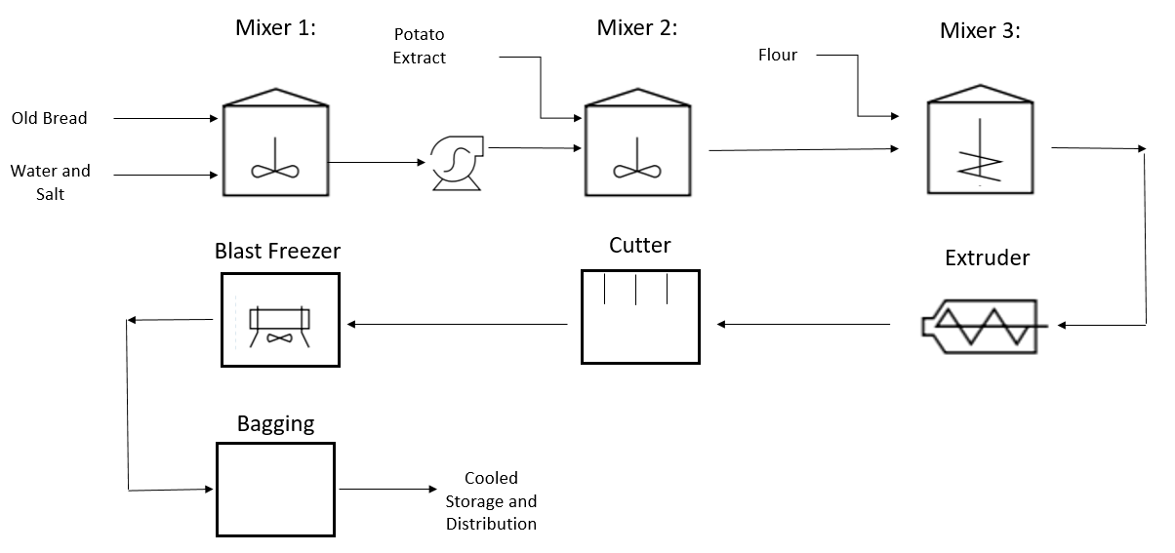

Figure 3: PFD of production process ‘raspatat’

Each step has its corresponding module, which can be expanded by adding a mixer, extruder, cutter or blast freezer.

#### Machine productivity

In the previous section, two of the three main point of influence on process efficiency are the availability and the energy efficiency. These factors are governed by the machine productivity. If a machine can produce as much as possible in the least amount of time with the lease amount of energy, its productivity rises. Highly specialized machinery however increases capital expenditure, which in turn increases cost price of products, so optimization of machinery and choice of unit operations is necessary.

From mixer 1 to the extruder, a screw pump is used to transfer the substance to the next module. The extruder then presses the substance to its intended square shape of the right dimensions. Due to the viscosity of the substance a cutter (which functions as a guillotine, where the product is transferred across subsequent belts) cuts the strings to the right length. A sharp cutting edge is required, but wear will be minimal as there are no seeds or pits in the used old bread (if this is the case then a proper filtration step has to be implemented, making the process significantly more complicated and costlier). Then the pieces of dough are introduced into a blast chiller by belt feed. The frozen fries are collected, sent to packaging. For the packaging material, the cost-effective solution would be standard plastic packaging. Recycled plastic is an option. Use of biodegradable plastics is not advised as this would reduce shelf life to maximum of 6 months and increase costs. The packaging will be fully automatic. This module is the most crucial as it has the most moving parts. Upgrading in packaging speed by adding extra packaging machines and line will be costly. Sufficient care and maintenance is crucial.

To maximize productivity, maintenance will have to be minimized. The screw pumps are of low maintenance. Due to low rotational speed and heavy-duty nature of the equipment, screw pumps can perform for years with minimal wear. The belts, if operated in a clean environment, should do the same. The packaging line has to be kept clean and moving parts sufficiently lubricated. The 2% of downtime (17 days per year on average) have to be used for maintenance of the packaging line and conditional check of other equipment. Perform maintenance preventively.

When operation of the process is performed in the above described manner productivity of the machinery and subsequently of the plant is maximized.

## Sensory Analysis of prototypes

Sensory research is done by an expert panel and the consumer. The expert panel consists of 7 people. The consumers are normal tasters and a target group that is chosen, consisting of 30 persons. The test location is a school canteen, here is a target group of students and teachers (various ages). The sensory research is done twice. The first time is with the three prototypes of raspatat and the second time is with the final product after optimization of the first sensoric test.

During product development, the product is continuously tested by an expert panel. The expert panel tests every batch on the sensory characteristics. For testing there has been set up a profile with the expected sensory characteristics as color, format, crunchiness, taste and aftertaste of different variations. The results of this profile test are presented in a spiderweb diagram within a ranking of 1 to 10. The expert panel will test analytical, this is a profiling test in which two products are compared; this test is only performed by an expert panel. The sensory properties of the original product will be compared with the new product in which bread is processed and the difference between the variations. Which gives a good representation of the measured differences between the product and the expectations. The questionnaire of the expert panel and the consumer test can be found in the appendix.

## Expert panel tests

Before performing the consumer test, an expert panel test has been done. The expert panel tastes the product and rating it on a scale from 1 to 10, a 5 is “just right” and doesn’t need further improvement according to the expert panel. Variation 1 consists of 50% potato powder and 50% bread, variation 2 consists of 50% potato powder and 100% bread and variation 3 consists of 100% potato powder and 50% bread.

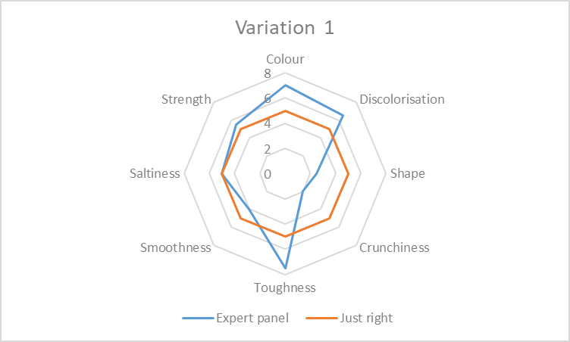

Figure 4 Results expert panel variation 1

The results of the expert panel test were put in a spiderweb. In figure 4 the results of variation 1 are displayed. In the spiderweb can be seen that variation has a bit too dark colour and the discolouration is high. The shape of the product was too small and inconsistent. The mouthfeel of the fries is rated on the crunchiness, toughness and smoothness. The crunchiness of the fries of variation 1 has been rated as soft, therefore has the toughness been rated higher. The smoothness, saltiness and strength of the aftertaste of the fries was rated overall with a good mark.

The second variation was rated the same way as the first variation, first on appearance. The colour of product was overall rated with a 5 which is just right. The discoloration was high, the colour was inconsistent, the shape was a bit big. The crunchiness of the fries is not consistent, one is crunchy, and another is soft. The fries were rated too salty. The smoothness of the inside of the fries and the strength of the aftertaste were on average just right.

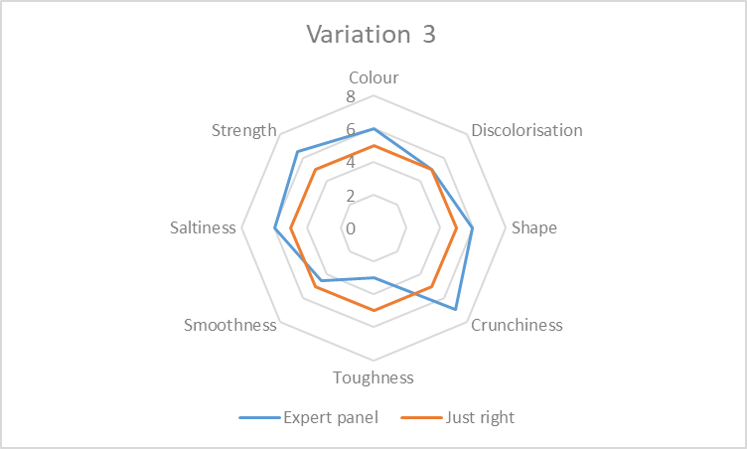

Figure 6 Results expert panel variation 3

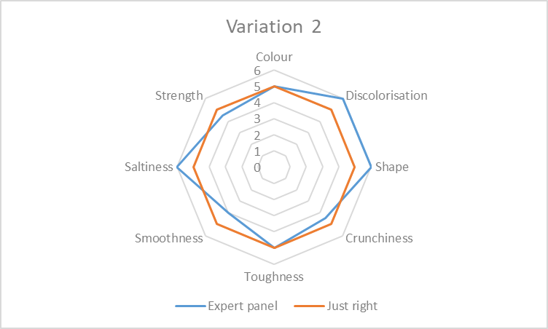

Figure 5 Results expert panel variation 2

The colour of variation 3 was too dark due to overcooking, the discoloration was just right because the fries were even coloured. The shape of the fries was sometimes too small and sometimes too big, on average the shape was a bit too big. The mouthfeel of the fries was also rated, overall were the fries were crunchy and were not tough due to the crunchiness. The inside of the fries was smooth which were just right according to the expert panel. This variation contained, just like variation 2, too much salt. The strength of the aftertaste was higher than the other variations.

## Consumer tests

The results of the consumer tests. A hedonic scale has been used. By color: weak - strong, format: small - large, crunchiness: weak - strong, taste: weak - strong, aftertaste: weak - strong. Eventually there was still asked for a total score (0 to 10). The last question was whether you will buy the product in the supermarket (yes/maybe/no).

Table results consumer test

|  |  |  |  |
| --- | --- | --- | --- |
|  | Variation 1 | Variation 2 | Variation 3 |
| Colour | 4,2 | 5,7 | 6,8 |
| Format | 3,8 | 6,3 | 4,8 |
| Crunchiness | 2,3 | 5,3 | 7,3 |
| Taste | 3,9 | 5,4 | 6,4 |
| Aftertaste | 3,9 | 5,0 | 5,9 |
| Total score | 5,8 | 7,0 | 6,8 |
| Supermarket | No/maybe | maybe/yes | maybe |

With the results of the previous consumer test, it was decided to continue with product "2". The product with twice as much bread than potato powder. The layout of the test was done in the same way as the previous consumer test (color, format, crunchiness, taste, aftertaste, total score and whether they would buy the product from the supermarket).

Table 5 Results final consumer test

|  |  |
| --- | --- |
| Colour | 7,1 |
| Format | 6,3 |
| crunchiness | 6,6 |
| Taste | 6,4 |
| Aftertaste | 5,6 |
| Total score | 7,6 |
| Supermarket | Yes/maybe |

## Results

Raspatat has a good shelf life of one month at a freezer temperature of -12°C but the shelf life tends to increase to one year when stored in a deep freezer at -18°C. Raspatat has a good shelf life of one month when stored in a freezer at a temperature of -12°C but the shelf life tends to increase to one year when stored in a deep freezer at -18°C. It also has a fair cost price of €4,72 per kilogram of the product. Production of Raspatat will prove to be efficient, when the resources are utilized in the appropriate ratios which reduces the chances of product rejection. It is important to use lesser energy as possible by making use of the right machinery and furthermore, the product can be continuously produced to increase product availability instead of producing it in batches. Raspatat is transferred to the market as a frozen product, and this is efficient as it increases its shelf life and therefore reduces the chances of microbial spoilage. The type of machinery to be used is vital and preferably they must produce large quantities of the product in a short space of time while using minimal amounts of energy. Packaging of the product preferably should be in recyclable plastic packages instead of biodegradable plastic packages as, they tend to reduce the shelf life of the product. Out of the three kinds of Raspatat variations formulated by the agency, the second variation (100% bread and 50% potato powder) was selected by the expert panel, because it contained twice the amount of bread as compared to other variations. Variation two also scored well during the expert panel test, because it had a good color and the shape was acceptable not forgetting its taste which was pleasing compared to the other variations. According to the consumer tests carried out, the second variation of Raspatat was more favored for by the consumers, who also pointed out the possibility of them buying the product, if it is placed on the market.

## Conclusion

Within the product definition phase, it is examined which of the three prototypes of the chosen product (raspatat) has the most potential.

From the result can we conclude that both the expert panel as from the consumers selected variation 2 (100% bread – 50% potato powder). This prototype meets the wishes of the customer, they would buy it. Besides that, is this the variation where the most bread can be processed.

# Final advice

In the end the product ´raspatat´ is chosen. Raspatat is easy to make and reduces a lot of the bread-waste stream. The recipe that would be advised to use for the raspatat can be found in appendix VIII Recipe Raspatat. Also, a general production process for the raspatatcan be found in chapter 5.1.3 Efficiency.

SustainiBread’s advice for raspatat or ‘bries’, is to package it in biodegradable sachets and freeze it before selling. This way the raspatat can be stored long and it is easy for the consumer to prepare the fries. According to the recipe 100 grams of fries contain about 1573 Kcal energy. It contains, 59 grams protein, 265 gram carbohydrates and 22 gram fat.

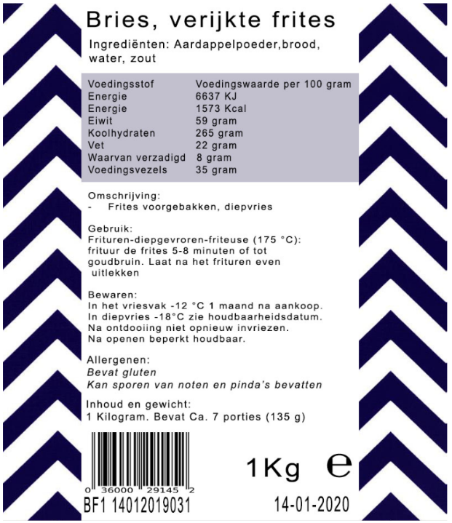The advice for preparing the fries is to fry it in fat with a temperature of about 175 degrees for 5 to 8 minutes and after frying to let the fat drip off for about a minute. The advice on storing the fries in the stores is to keep it in the freezer on -12°C degrees and don’t keep it longer than a month on that temperature. The fries can be stored for a year at -18°C

The advice concerning marketing, would be utilisation of social media platforms such as facebook, instagram and youtube to name a few and these can be used to advertise Bries, either by use of pictures or videos together with information about the product. In this era of internet usage, many people are on one social network or more and such networks provide the chance to reach out to new audiences and alert them of Raspatat or Bries. Social media is a good tool because reviews on the product can easily be made by consumers and if there are positive reviews, they will attract more people to have the desire to try Bries for themselves.

# Press release

--------------------------------------------------Press release-----------------------------------------------------

Students Van Hall Larenstein develop sustainable new product for Foundation Grien

LEEUWARDEN- Students from Van Hall Larenstein in Leeuwarden have worked for 10 weeks on the development of a new product for Foundation Grien by using unsold bread. The product is developed to reduce the largest waste stream in the Netherlands. After development the ‘bries’ was born as a new product.

Foundation Grien, organizer of the Verspillingsmarkt, has introduced a new product to tackle the problematic food waste in the Netherlands developed by students of Van Hall Larenstein. The new product; ‘Bries’ is made with unsold bread. Bread is seen as a fresh product in the Netherlands, it is intended to be sold the same day as it is baked. Ten percent (10%) of all products is waste, for bread this amounts to a total waste of a 160 million kilograms per year nationally. Bries are made with the unsold bread, one kilogram of Bries saves almost a complete loaf of bread. The fries have the same taste, look and smell as regular “raspatat” but it contains more fibers, which makes the fries a healthier choice for dinner or as a snack.

--------------------------------------------End of Press release----------------------------------------------

Note for editorial:

For more information please contact:

Theo Jansma [theo@grien.nl](mailto:theo@grien.nl)

Or

Lisan Siemonsma [lisan.siemonsma@hvhl.nl](mailto:lisan.siemonsma@hvhl.nl)

# Bibliography

Toby Amidor. (2018, December 02). *Brown vs white the case of the breads*. Retrieved from Tobyamidornutrition: http://www.tobyamidornutrition.com/2012/05/brown-vs-white-the-case-of-the-breads/

Centraal bureau voor de statistieken. (2004, Oktober 4). *Consumers remain loyal to bread*. Retrieved from CBS: https://www.cbs.nl/en-gb/news/2004/41/consumers-remain-loyal-to-bread

Chapp, T. (2018, Februari 1). *Industrial Refrigeration: Ammonia and CO2 Systems*. Retrieved from Food for thought: http://stellarfoodforthought.net/industrial-refrigeration-ammonia-and-co2-systems/?doing_wp_cron=1548891525.0583050251007080078125

Federation of Bakers. (n.d.). *European bread market*. Retrieved from Federation of bakers: https://www.fob.uk.com/about-the-bread-industry/industry-facts/european-bread-market/

Grace Elkus. (2018, December 02). *Whole wheat whole grain breads*. Retrieved from Realsimple: https://www.realsimple.com/food-recipes/cooking-tips-techniques/whole-wheat-whole-grain-breads-0

*Investment.* (2019). Retrieved from https://cma.org.sa/en/Awareness/Publications/booklets/Booklet_1.pdf

Jessica Bruso . (2018, December 02). *Whole grain bread vs white bread*. Retrieved from Live strong: https://www.livestrong.com/article/289338-whole-grain-bread-vs-white-bread/

*The difference between bread*. (2018, December 02). Retrieved from quarter past normal : http://www.quarterpastnormal.com/thedifferencebetweenbread/

# Appendices

# I Results creativity session

**Memopad brainstorm, orderd in blue, red or yellow ideas**

|  |  |  |
| --- | --- | --- |
| Blue | Red | Yellow |
| Liquor products | Bread & chocolate | Soft drinks |
| Croutons | Chips | Merengue |
| Baquette | Apple pie | “Sustainy bread” |
| Bread pudding | Breadmix/pancakemix | Brinta/goedemorgen |
| Rusk | Ice cream | Bread cream |
| (corn) flour | Chocolate/energy bar | Bread spread |
| Crackers/biscuits | Bread ragout | Fiber supplement |
| Crumbs | Bread soup |  |
| Breadsticks | Bread sausage |  |
| Ice cream cane | Bread flakes, granola |  |
| Bun | Nut coating |  |
| Cookies | Lasagne/spaghetti |  |
| Cake | Morning cake |  |
|  | Tortilla |  |

**Alphabetic brainstorm**

|  |  |
| --- | --- |
| A | Alcoholic drink  Apple pie  Appearance |
| B | Beverage  Banana bread  Brownie |
| C | Cheap  Chocolate  Chips  Cookie  Colour  Childhood |
| D | Doughnut |
| E | Energy  Efficient |
| F | French toast  Fermenting  Flavour |
| G | Gingerbread  Gravy  Gluten-free |
| H | History  Home made  Healthy  Hot |
| I | Ice cream  Innovation |
| J | Joy |
| K | Kinds of bread |
| L | Looks  Lactose-free |
| M | Multipurpose  Market trend |
| N | Nutritious |
| O | Original |
| P | Pre-packaged  Pepernoten  Processing time <  Pizza  Pretty |
| Q | Quantity & quality  Quick |
| R | Risk |
| S | Sauce  Sugar bread  Savoury/sweet  Sustainability  Shelf life |
| T | Taste and texture  Target groups  Transport  Tasty |
| U | Useful  Unique |
| V | Vegan  Viability  Value ability |
| W | Wodka |
| X | Xanthine |
| Y | yeast |

# II Recipe chocolate paste/bread sauce

Chocolate paste

* 600 gram chocolate
* 300 gram white caster sugar
* 300 gram butter
* 600 ml condensed milk
* Bread paste
  + 0 % for reference
  + 10-120%

Method:

Heat the condensed milk with the white caster sugar until the sugar has completely dissolved into the condensed milk, do not let the condensed milk boil. Add the butter and the chocolate until it has become a smooth mixture. Cool off and put in a container and mix the different percentages into the paste.

Bread sauce

* Mayonnaise
* Red pesto
* Sun dried tomatoes
* Bread paste
  + 0% for reference
  + 60 – 90%

Method:

Cut the sundried tomatoes in to small pieces, put it in a bowl with the red pesto and the mayonnaise. Mix until it becomes a whole. Put in containers and mix different percentages of bread paste in to the sauce.

# III Recipe Pizza crust

Ingredients:

2 ½ cups bread flour (300grams bread flour)

2 ½ teaspoon yeast

1 tablespoon sugar

¾ teaspoon salt

2 tablespoon olive oil, plus additional for oiling the bowl

2 teaspoon salt

150ml lukewarm water (around 45°C)

Method:

Blend small pieces of bread. Add water, yeast, sugar, salt, olive oil and bread flour into the mix. Knead the dough into a ball and let it rest for 30 minutes. Preheat the oven to 215°C at this point so that it will have reached temperature once the pizza is ready to bake. 8. Once the dough has risen, gently deflate it using hands and transfer to a lightly floured surface and knead briefly until smooth. Make the dough into small circles. 10. Transfer dough to a parchment paper lined pizza pan and either pinch the edges or fold them over to form a crust. Bake at 215°C for 13-15 minutes. Pizza crust is ready to be served.

# IV chocolate balls

**70 gr egg white**

**70 gr Castor sugar**

**70 gr icing sugar**

**70 gr breadcrums**

**200 gr milk chocolate**

Whisk the egg whites and as they start to go fluffy, gradually add the granulated sugar.

Keep whisking until firm and glossy. Then add the breadcrums, still whisking.

Seive the icing sugar and fold it gently in your meringue.

Line a baking tray with baking parchment and pipe tiny little meringues. Make them really small, as once coated with chocolate, they’ll be much bigger.

Put in a oven at 100C. Take them out 1 hour after and let them cool down.

Slowly melt your chocolate and pour it in a tall container like a thin mug or a long glass. This will help you dip the meringues easily.

Take a toothpick and stab the flat bit of your meringue, be delicate with it or it will break. Dip it in the chocolate and let it dry on a tray.   
You may need more chocolate, depending on its texture.

# V Recipe donut

Ingredients:

375 gram bread (without crust, only soft part)

1 package yeast (7 g)

40 gram sugar

pinch of salt

2 egg yolks

150 ml milk (lukewarm)

60 g of margarine (melted and cooled)

Sugar as a topping

Method:

Blend small pieces of bread with yeast. Add the sugar, salt, egg yolks, milk and butter and knead with a mixer with dough hooks first on the lowest setting and then on the highest setting, in about five minutes until a dough is created. Cover the bowl with plastic wrap and let it rise for half an hour at room temperature. Sprinkle a worktop with a thin layer of flour and knead the dough again briefly. Roll it out into a 1 cm thick sheet. Insert circles with a diameter of 9 cm, then put a small circle out of the middle, so that it is a donut form. Place the rings on a plate or baking tray. Cover it with the foil and let it rise again for half an hour. Heat the deep fryer to 180 ° C. Bake the donuts gold brown on both sides. Put the donuts in a colander to let them drain and cool.

VI Recipe Chipsng, in about five minutes until a dough is created. Cover the bowl with plastic wrap and let it rise for half an hour at room temperature. Sprinkle a worktop with a thin layer of flour and knead the dough again briefly. Roll it out into a 1 cm thick sheet. Insert circles with a diameter of 9 cm, then put a small circle out of the middle, so that it is a donut form. Place the rings on a plate or baking tray. Cover it with the foil and let it rise again for half an hour. Heat the deep fryer to 180 ° C. Bake the donuts gold brown on both sides. Put the donuts in a colander to let them drain and cool.

# VI Recipe Chips

Ingredients:

0,5 gram bread

0,5 L water

0,5 gram potato powder

5 table spoon corn starch

8 table spoon potato starch

Pinch of salt

Pinch of pepper

Method:

First the bread needs to be sliced into small pieces. Then all the water needs to be added and it should be blended with a mixer until it is a smouth mix. After this the potato powder needs to be added and it should be mixed with a dough hook. When the potato powder is all mixed trough the corn starch, potato starch, salt and pepper can be added. Then the dough should be rolled out until it is about 2 mm thick, after this the shapes can be cut out and the shapes can be fried for half a minute in 160°C frying oil. When the shapes are fried there can be added a little salt for the top and the chips are ready.

# VII Breadball

2 pieces of carrots (190 gram)   
1 red pepper (140)   
2 tomatoes (300)   
1 onion (70)   
20 gram of tomato ketchup   
5 gram hot spice powder   
5 gram white peper   
5 gram salt   
5 gram red pepper powder   
5 gram cumin powder   
40 gram flour   
Whole bread

Boil the carrot for 8 minutes   
Make little pieces of the carrots, pepper, tomatoes and onion.   
Put the vegetables, herbs and flour in a bowl.    
Take 8 slices of bread, make the bread a little bit wet.    
Make also little pieces and put them in the bowl.   
Mix everything for 5 minutes.    
Make balls of 50 gram    
Fry the balls for 3.5 minutes 

# VIII Recipe Raspatat

Ingredients: *variation 1*

0.25 kg potato powder

0.25 kg ground bread (without crust, only soft part)

0,75 liters of water

pinch of salt

Ingredients: *variation 2 (final product)*

0.25 kg potato powder

0.5 kg ground (without crust, only soft part)

0,75 liters of water

pinch of salt

Ingredients: *variation 3*

0.5 kg potato powder

0.25 kg bread grinded (without crust, only soft part)

0,75 liters of water

pinch of salt

Method:

Blend small pieces of bread with water. This creates a kind of mashed potatoes mix. Add potatopowder and a pinch of salt and mix again. The dough is brought to texture with flour and pressed into shape, resulting in the well-known long fries (raspatat). The fries need only be fried for 1.5 minutes at 175 ° C. Before serving there can be chosen to add a little bit salt on the fries.

# IX Bread Cereal

Ingredients:

4 cups of bread

2 tablespoon granulated sugar

½ teaspoon coarse salt

2 teaspoon vanilla extract

5-6 cups of water

**Method**

1. Preheat oven to 350 Fahrenheit degrees. Line a baking tray with parchment paper or foil and grease lightly with oil or baking spray.
2. Cut bread into small pieces and add little water at a time while mixing the bread pieces with a mixer till you get a soft like paste.
3. Measure 4 cups of bread paste and place it in a new bowl, add 2 tablespoons of granulated sugar, ½ teaspoon of coarse salt and 2 teaspoons of vanilla extract. Mix them together while adding water if the mixture is too dry.
4. Pour the mixture into a baking tray and spread it evenly as thinly as possible.
5. Place tray in oven and bake for 1-2 hours till the mixture has dried up.
6. Take the tray out and tune oven to 250 Fahrenheit degrees and mean while break the cereal into small pieces.
7. Place the baking tray with the cereal in the oven for about 1 hour till the cereal attains a golden colour and are crispy enough.
8. Let the cereal cool before serving with milk and if there are leftovers place them in an air tight container.

IX Recipe Chocolate Balls

Ingredients:

70 gr egg white

70 gr Castor sugar

70 gr icing sugar

70 gr breadcrums

200 gr milk chocolate

Method:

Whisk the egg whites and as they start to go fluffy, gradually add the granulated sugar.

Keep whisking until firm and glossy. Then add the breadcrums, still whisking.

Seive the icing sugar and fold it gently in your meringue. .

Line a baking tray with baking parchment and pipe tiny little meringues. Make them really small, as once coated with chocolate, they’ll be much bigger.

Put in a oven at 100C. Take them out 1 hour after and let them cool down.

Slowly melt your chocolate and pour it in a tall container like a thin mug or a long glass. This will help you dip the meringues easily.

Take a toothpick and stab the flat bit of you meringue, be delicate with it or it will break. Dip it in the chocolate and let it dry on a tray.  
You may need more chocolate, depending on its texture.

# X Questionnaire expert panel test







# XI Questionnaire consumer tests

Wat vind je van de sterkte van de kleur?

Zwak Sterk

Wat vind je van het formaat van de patat?

Klein Groot

Wat vind je van de knapperigheid?

Zwak Sterk

Wat vind je van de smaak?

Zwak Sterk

Wat vind je van de nasmaak?

Zwak Sterk

Totale score:………

Opmerkingen:

Zou je dit product kopen in de supermarkt?

* Ja
  + Omdat………………………………………………………………………………………………………….
* Misschien
  + Omdat………………………………………………………………………………………………………….
* Nee
  + Omdat………………………………………………………………………………………………………….